Flamingo and Panda Mamas Supply list and pre-workshop instructions.

**Paint:**

Professional grade tube watercolor paints like Sennelier (I love their l’Aquarelle watercolor paint), Daniel Smith, Schminke, Holbein, Winsor & Newton, etc.  **Colors:**

* Opera (or close to this color)
* Alizarin Crimson (or close to this color)
* Cadmium Yellow (or close to this color)
* Cobalt Blue (or close to this color)
* Phthalo Blue (green shade) (or close to this color)

**Brushes**

* A #16 round watercolor brush. I suggest a combination of natural and synthetic hair. Don't go too cheap.
* A smaller #6 or #8 round watercolor brush.
* A soft graphite drawing pencil (I use a soft Ticonderoga office pencil).

**Paper**

* One 22” x 30” full-sheet, 140lb cold press, professional-grade watercolor paper cut into two 15” X 22 inch half-sheets. I suggest buying Fabriano Artistico or Arches extra white watercolor paper**.**
* **Palette**
* A good-sized rectangular plastic palettewith paint wells around the outside, with a good-sized mixing area inside. The palette should measure about 10x16". There are various manufacturers of these palettes, but they are all around this size and configuration.

**Additional materials**

* A roll or two of absorbent kitchen paper towels.
* One white chalk marker. There are numerous brands on the market, but they are all essentially the same. My fav. brand is a white Bistro chalk marker.
* Something to hold about a **quart of water**. If you want to go fancy pants, I’d suggest the Mijello-brand water buckets (the one that holds about a liter of water).
* A small to medium water spritzer.

**HOMEWORK -** *To be done before the workshop date.*

**Stage 1:** Print the outline drawings that I have included on your home printer.You will eventually need to trace both scenes, each to fit snugly fit onto the watercolor half-sheets.

**Stage 2: Use my outline drawings and make enlarged copies** using a plain paper copier so that each of the animal scenes fits onto the half-sheets as close as possible to the samples shown below. You can use a copier service to do this (there are even online enlargement services). If you have a digital projector, that may be a way to go. The enlarged drawing can be projected directly onto your sheets of watercolor paper and traced..

**Stage 3:** You can now take the enlarged plain paper outline drawings and trace them onto your two half-sheets of watercolor paper. Apply a little extra pressure on your pencil as you trace so that the tracing is not too light. You can use a light table (i.e., an inexpensive, lightweight, and LED light table, if you don’t already have one) or use a window during daylight hours. are not too light and

**Don’t forget to bring the reference photos to the workshop**. **You will need to refer to them during the entire painting process.**

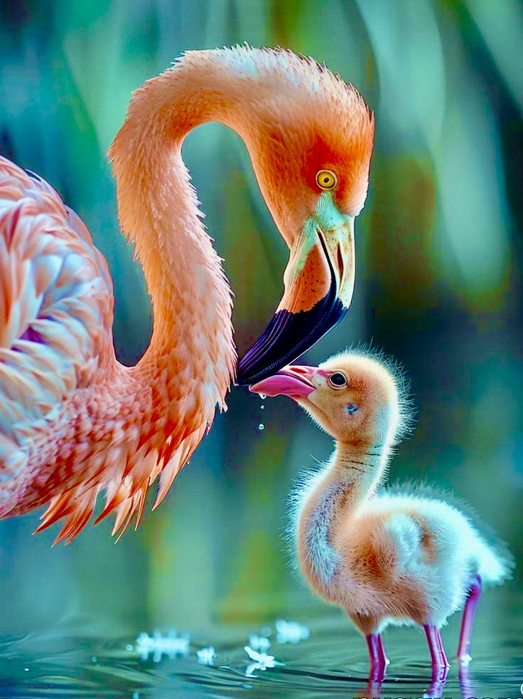

The flamingo reference photo. Please make a print and bring it to the workshop.

The Panda reference photo. Please make a print and bring it to the workshop.

The flamingo outline drawing is to be enlarged for tracing.

This shows you how the painting fits within a quarter-sheet.

Panda outline drawing to be enlarged for tracing.

This shows how the painting fits within a quarter-sheet.